Lab Exercise -8: Tree and Heaps

Perform the following in C/ C++.
Binary Tree

1. Write a program to implement a Binary Tree using an Array.
Include the following operations:
Insert elements into the binary tree. o Display the binary tree as an array. o Perform In-order, Pre-order, and Post-order Traversals using the array.
• Instructions: Use a 1D array to store the binary tree where the left child of a node at index i is stored at 2*i + 1 and the right child at 2*i + 2. Test with different inputs to insert elements and perform traversals.
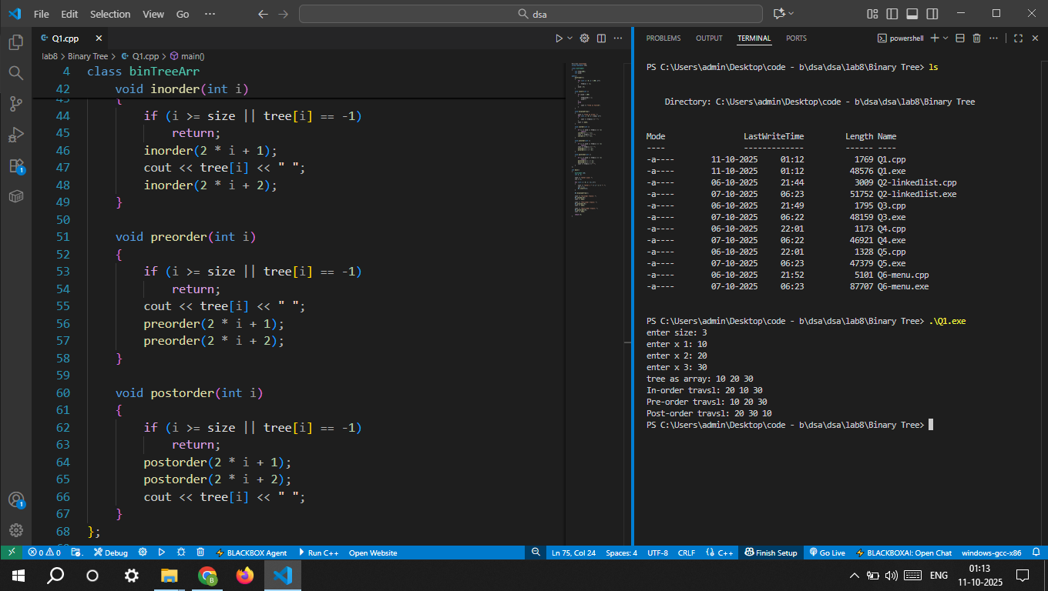

2. Implement a binary tree from scratch in C or C++. Include functions to:
o Insert a node into the tree. o Display the tree using Pre-order, In-order, and Post-order traversals. o Find the height of the tree. o Count the total number of nodes. o Count the number of internal nodes. o Count the number of leaf nodes (External nodes). •
Instructions: Write separate functions for each of the above tasks. Test your implementation with a sample tree.
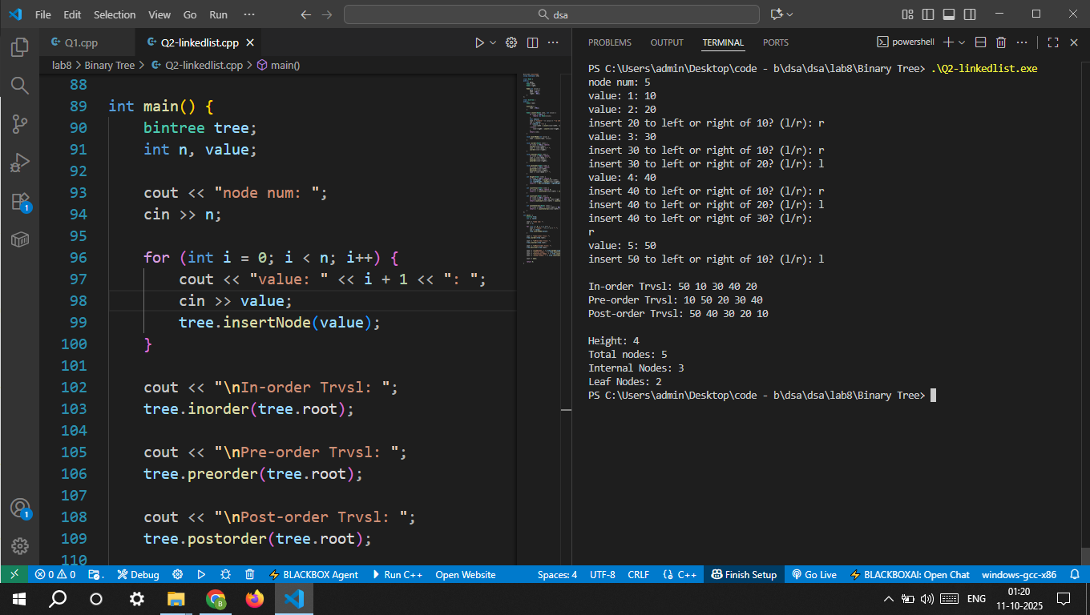

3.Implement a function to compute the Mirror Image of a Binary Tree
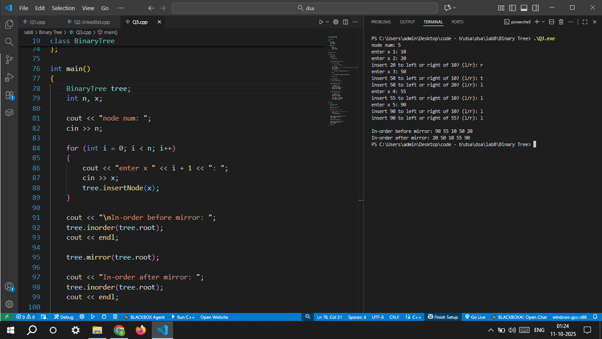

4. Implement a program to perform a Level-order Traversal of a binary tree that is stored in an Array. • Instructions: Given an array representing a binary tree, print the elements level by level. Use the array index to determine the children of each node as described in the previous exercise.
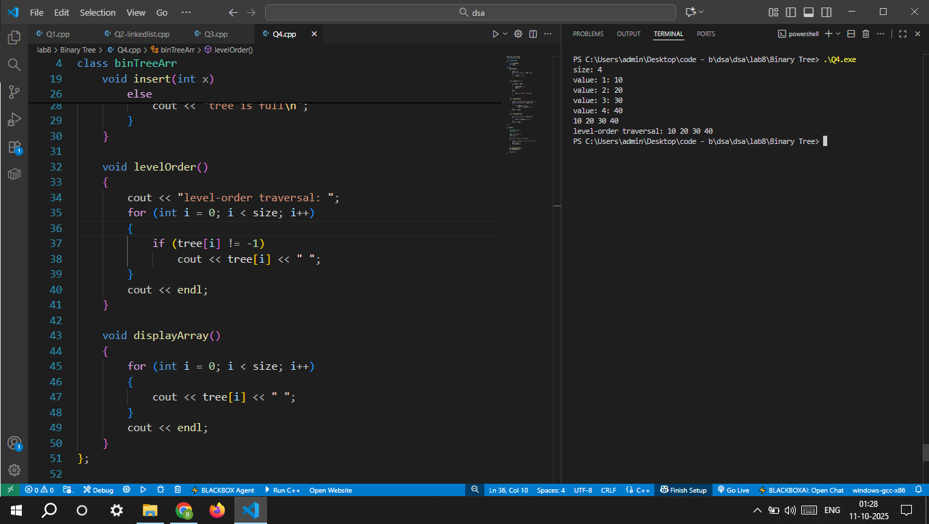

5. Write a program to check if a given Binary Tree stored in an Array is a Complete Binary Tree. • Instructions: Use the properties of a complete binary tree to verify if the array representation satisfies the conditions. Test the function with various array inputs.
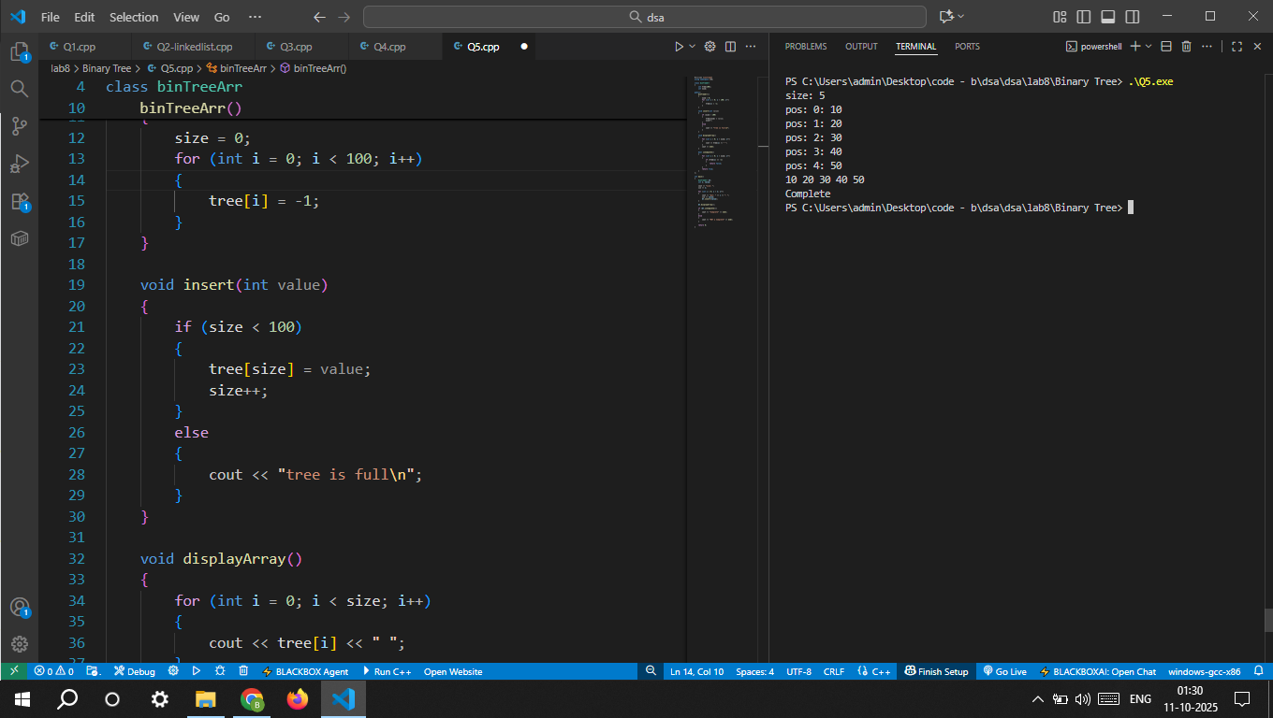

6. Write a program to implement a Binary Tree using Linked Lists. The tree should support the following operations: o Insert a node into the binary tree. o Delete a node. o Perform In-order, Pre-order, and Post-order Traversals. • Instructions: Create a binary tree where each node has left and right pointers. Write functions to insert nodes and perform different types of tree traversals.